Use this reference to verify and review attendance.

INSTUCTIONS – Verify and Review Attendance

- Log into Workday and enter the Teaching app.



- Locate the Attendance Tracking heading and click “Verify Participation for My Course Section”.

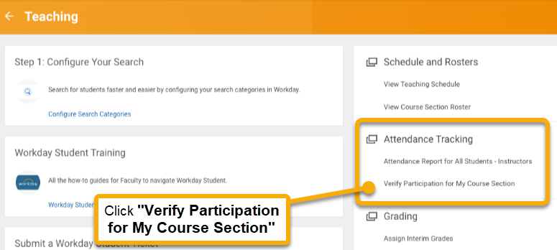

- In the Verify Participation for My Course Section window, click the Published Course Section field.

- Select the academic period corresponding to the course section.

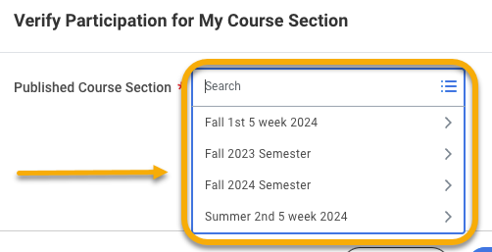

- Select the course section.

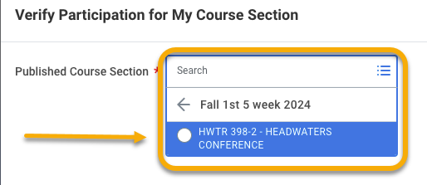

- Click “OK”.



- The Verify Participation for My Course Section page will appear for the selected course. All enrolled students will default to “attending”.

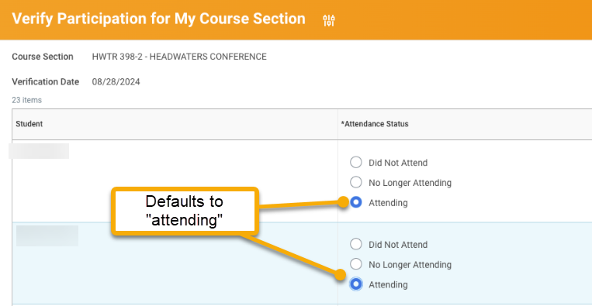
- Locate students who did not attend or are no longer attending. Locate the Attendance Status column and make changes, as needed.

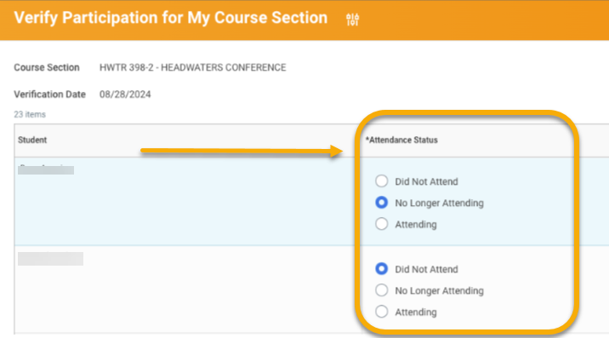

Selecting “No Longer Attending” will trigger a date field in the Last Date of Attendance column. Enter an estimate of the student’s last date of attendance.

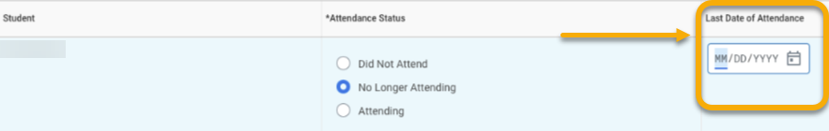

- To review attendance, return to the Teaching app dashboard. Locate the Attendance Tracking heading and click “Attendance Report for All Students - Instructors”.

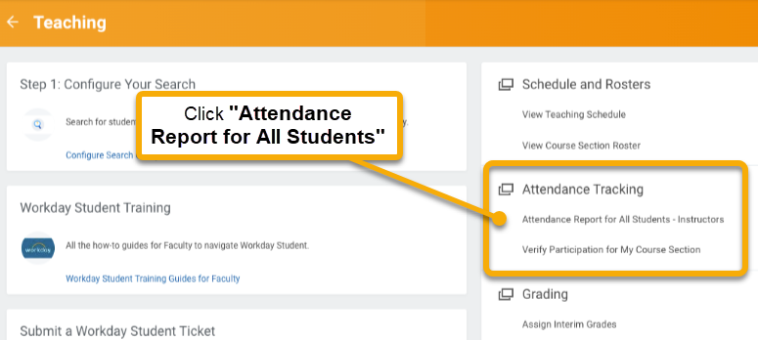

- A search window appears with instructions on selecting the student population for whom you want to view attendance. Set the filters as needed.

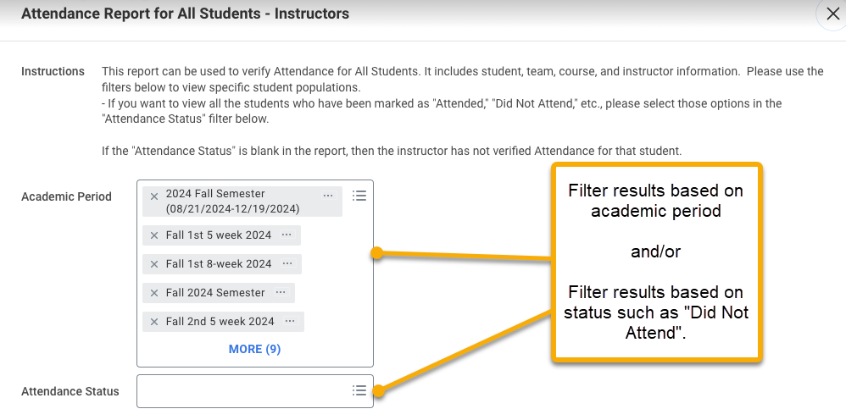

- Click “OK”.



- The results window will display the selected search filters at the top and the results in a table below. The right-hand column displays the attendance status for each student.

Note: If the results are not what you are looking for, return to the search window and adjust your filters.

